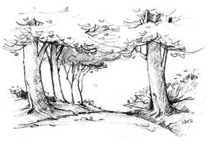
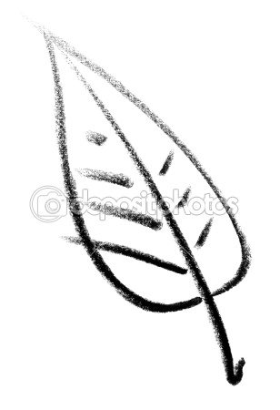
Ms. Bindschadler
cab4@email.arizona.edu
Freshman English
Sahuaro
High School
2011-2012

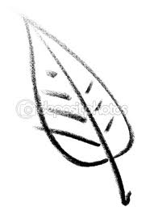
Literature is news that stays news
- Ezra Pound

All literature is gossip
-Truman Capote

What is Literature? Literature is the immortality of speech
-August Wilhelm Von Schlegel

Literature becomes the living
memory of the nation
- Alexander Solzhenitsyn

Literature is the question
minus the answer
- Roland Barthes

Classroom Procedures
Make-up Work:
Students are responsible for seeing me after an absence. Conference Periods are mandatory on Tuesday and Thursday mornings if you have been absent or your grade is below a C. Also attend Conference Period if you need extra help or tutoring for any reason. Absent work will be accepted within the number of days you were absent, plus one.

Homework:
Students will be expected to complete weekly vocabulary homework, to be turned in every Monday. During the Spring semester, we will be focusing on 9th grade SAT words—The Hundred Words Every Freshman Should Know.
Students are also expected to complete a book project for at least one book they have read outside of school each quarter. Book projects are due the 2nd to the last week of each quarter. Any work not completed in class will be taken home to be finished as homework, and turned in the next day for credit.

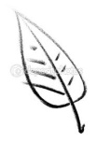
Late Work:
You will be given 3 NQA (No Questions Asked) assignments per semester. This means that you are allowed to turn in three assignments late without penalty. In order to redeem your NQAs, you must write “NQA” at the top of the assignment when you turn it in or it will be counted late. If by the end of the semester, you have not used your NQAs, you will be able to redeem them for extra credit, only if you have no other late work. Any other late work will lose one letter grade for every day that it is late. If it is more than one week late, it will not be accepted.

Attendance:
Your presence is necessary to receive all of the information you need in order to pass this class. Please take responsibility for your attendance. District and school attendance and tardy policies will be enforced.

Electronic Devices
Cell phones are permitted only when specific permission is given. If I see a cell phone out at any other times, I will take it away until the end of the day. Headphones and music devices will be allowed during quiet work or reading days as long as they are not bothering any other students. If they are out during instruction or a classroom discussion, they will be taken away.
Class Website
If you have any questions regarding homework, book projects, classroom activities, or the weekly agenda, please consult the class website. A class calendar will be posted weekly. This website also contains information and extra resources for each of the units we will be studying this Spring. The web address is:
http://ericksonsenglishclasses.weebly.com/index.html
You can also access is from the Sahuaro home page.

Plagiarism is the use of someone else’s words or ideas and the presentation of those ideas as though they are entirely one’s own. Acts of plagiarism include, but are not limited to:

- Using works or ideas from a published source without proper documentation
- Using the work of another student (ex. Copying another student’s homework, composition, or project)
- Copying and pasting from the internet with or without editing
Plagiarism on any project or paper will result in a zero for the assignment. Students who willingly provide another student access to their work will also receive a grade of zero for that assignment. I want to see your learning and knowledge on the work you turn in, not someone else’s. If you plan on collaborating with someone else on an assignment, please talk to me first.

Major Topics We Will Cover
Tragic Love and Passionate Death
Main Text: Romeo and Juliet by William Shakespeare
Supplementary Texts:
- Zeffirelli’s Romeo and Juliet (1968)
- Lurhman’s Romeo and Juliet (1996)
The Power of Words
Main Texts:
- “I Have a Dream,” by Martin Luther King, Jr.
- “I Am the First Accused,” by Nelson Mandela
Heroes and Journeys
Main Text: The Odyssey by Homer
Supplementary Texts:
- Tennyson’s “Ulysses”
- Andrei Konchalovsky’s The Odyssey (1997)
Time Capsules—The Realities of Writing
This unit will focus on a variety of writing prompts including:
- Resumes, Business Letters, Personal Narratives, Job Research …And more!
At the end of the unit, we will create time capsules to contain all of the writing from this unit—students work will be preserved for their future use.

Classroom Rules
Be Responsible
Come to class on time, and be prepared with all necessary materials. Turn in assignments in a timely fashion, and be a positive and active force in the classroom.
Be Respectful
Listen when others are speaking, whether that person is the teacher, or a fellow student. Do not put down one another’s work, and be aware of appropriate classroom language and comments.
Be Courageous
Be willing to try new things, and to open your mind to new ideas. This classroom is a safe space for discovery and expression, so take a deep breath, and be willing to be surprised.

Behavioral Consequences
Positive | Negative
- Verbal Praise  - Seating Preference  - Extra NQA  - Phone call/Email home | - Verbal Warning  - “Time-out”/ Removal from classroom  - Call/email home  - Referral to Administration

Grading Policy
A = 90-100%
B = 80-89%
C = 70-79%
D = 60-69%
F = 0-59%

Supplies needed:

- English/Homework folder (there will be random folder checks, so this should always be in your possession
- pens/pencils
- Highlighters (5 assorted colors)
- Bellwork Notebook
- lined paper
- Flash drive
- Positive Attitude

Course Expectancy Quiz
This must be returned to me for credit

What are the titles of the three units we will cover this semester?

Which unit are you looking forward to the most and why? Are there any units you have concerns about? Why?

What does NQA stand for?
How many NQAs do you get a semester? What do you have to do in order to make an

assignment count as an NQA?

What should you bring to class every day?

Which quote about literature appeals to you the most? Why?

By signing below I acknowledge that I have read and understood the policies for the Spring semester.

Student Signature

Parent/Guardian Signature:
Welcome Back Cougars!

